What is the High School & Beyond Plan? | The High School & Beyond Plan (HSBP) is a Washington State graduation requirement.  The HSBP helps students focus on setting goals, as well as preparation and readiness for future work, career, training, and/or college.  Starting in middle school, students begin developing their HSBP and continue revising their plan each year throuth 12th grade as their interests and/or goals change.
- Your High School & Beyond Plan completion shows up on your official transcript as MET. | 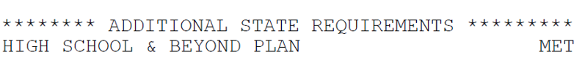
- Log into Naviance | 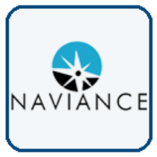  Username: district ID#  Password: district password
- Complete the questions on My High School and Beyond Plan Senior Year Survey. | Notice the questions marked with a red asterisk * are required questions.  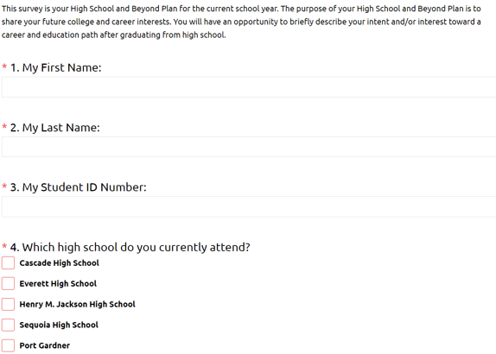
- For both the Math & ELA pathway questions, mark one or more graduation pathways that apply to you.  (*If you are unsure how you are meeting a Math or ELA pathway, please contact your counselor) | Math Graduation Pathways:  - Meet standard on math Smarter Balanced Assessment  - Complete and qualify for college credit in a dual credit math course  - Earn credit in a high school math transition course (Bridge to College)  - Earn a C+ or higher in a qualifying AP math course OR 3 or higher on an AP Math exam  - Meet standard on SAT OR ACT in math  - Meet standard on the Armed Service Vocational Aptitude Battery (ASVAB)  - Complete a qualifying sequence of career and technical (CTE) courses  - Meet Standard on math WA-AIM
ELA Graduation Pathways:
- Meet standard on ELA Smarter Balanced Assessment
- Complete and qualify for college credit in a dual credit math course
- Earn a C+ or higher in a qualifying AP ELA course OR 3 or higher on an AP ELA exam
- Meet standard on SAT OR ACT in reading, writing, or English
- Meet standard on the Armed Service Vocational Aptitude Battery (ASVAB)
- Complete a qualifying sequence of career and technical (CTE) courses
- Meet Standard on ELA WA-AIM
- When answering questions about your college choice, please indicate your acceptance status if you know it. If not, you can update it later. | 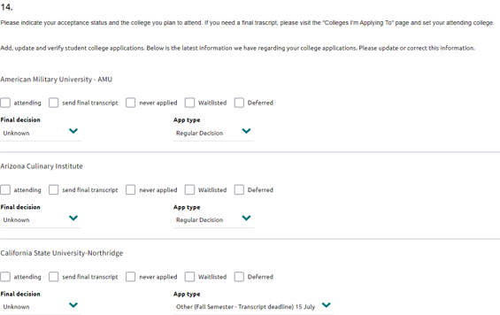
- For questions using a 1-5 rating scale, read each question and answer based on your own experience. | 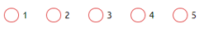
- Task Completion: | Click on Planner>Tasks  Click the title of the task, Complete FALL Senior Yr. High School & Beyond Plan Survey

